**Document Type: QA Test Result**

Report Name: 9C_A_01 Item wise daily Sell

Tester Name: Md. Amin Khan

Test Date: 24-10-2023

**Browser**: Microsoft Edge

In UI & PDF:

Data is mismatched in DB & Report, Reference: Parameter Used: From: 23-09-2023 To: 23-10-2023

I**n DB query:** [SELECT](http://159.223.67.50/phpmyadmin/url.php?url=https://dev.mysql.com/doc/refman/8.0/en/select.html) var_item_info.display_itm_name_bn, [SUM](http://159.223.67.50/phpmyadmin/url.php?url=https://dev.mysql.com/doc/refman/8.0/en/aggregate-functions.html%23function_sum)(trns03b_issue_child.item_rate) AS total_item_rate, [SUM](http://159.223.67.50/phpmyadmin/url.php?url=https://dev.mysql.com/doc/refman/8.0/en/aggregate-functions.html%23function_sum)(trns03b_issue_child.issue_qty) AS total_issue_qty, [SUM](http://159.223.67.50/phpmyadmin/url.php?url=https://dev.mysql.com/doc/refman/8.0/en/aggregate-functions.html%23function_sum)(trns03b_issue_child.total_amount_local_curr) AS total_amount_local_curr FROM trns03a_issue_master JOIN trns03b_issue_child ON trns03a_issue_master.id = trns03b_issue_child.issue_master_id JOIN var_item_info ON trns03b_issue_child.item_info_id = var_item_info.id WHERE trns03a_issue_master.issue_date BETWEEN '2023-09-23 00:00:00' [AND](http://159.223.67.50/phpmyadmin/url.php?url=https://dev.mysql.com/doc/refman/8.0/en/logical-operators.html%23operator_and) CURDATE() GROUP BY var_item_info.display_itm_name_bn;

**Results:**

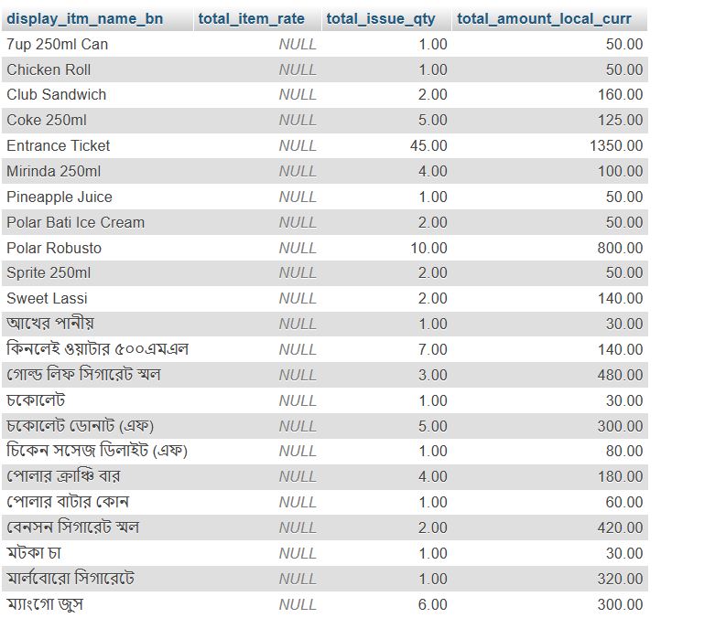

In System Report is showing:

